American Sign Language Detection

Team #8

Team members:

Ahmed Essam El-deen Sadek 1 3
Ahmed Mohamed Zakaria 1 4
Abdullah Ezzat 1 34
Omar Ahmed Desoky 1 37

Used Algorithm:

Hand Detection
- Smoothing using Gaussian filter to remove noise.
- Segmentation by skin tune Using Log-Chromaticity.
- Background Subtraction.
- Face Removal using Haar Cascade.
- Closing to fill hand.
Feature Extraction:
- Find Contours to get the largest Contour (Hand).
- Convex Hull of the hand.
- Convexity defects to get defects in the convex hull.
Classification:
- Classify hand based on Num of finger in each direction,Orientation and Bounding box aspect ratio.

Results and Analysis:

First we used color model which is a combination of HSV ,YcbCr and RGBA Color spaces.

Results:
- there are a lot of false negatives as Shown in Figure(1)
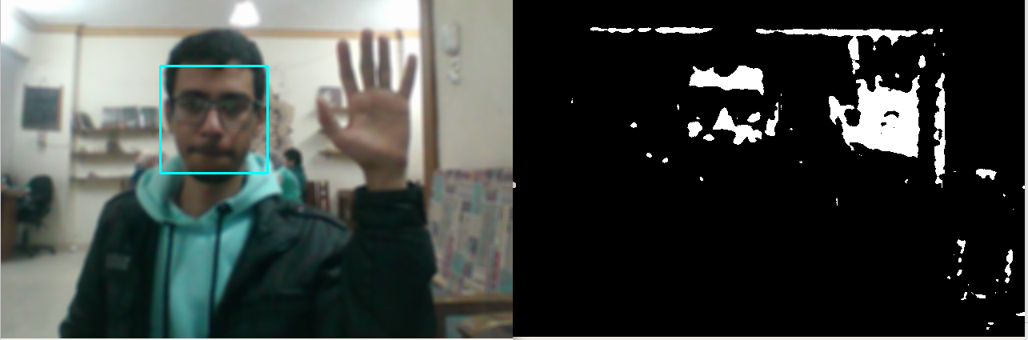 Figure(1)

- So we finally used log chromaticity as shown in Figure(2)

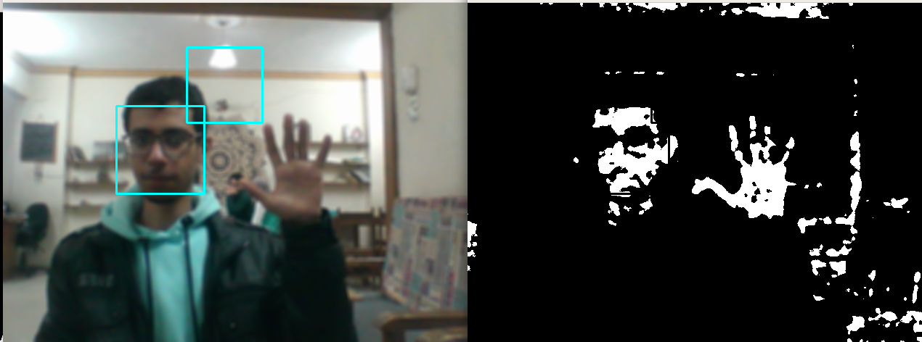Figure(2)
- regarding face removal, we tried first to use the aspect ratio of the contours of the binary image to filter hand from face, but it gives nearly 65% accuracy, that happens due to different orientations and dimensions, also if hand is closed it’s almost the same as face.
- So we used Haar cascade Classifier to Remove Faces from image as Shown in Figure(3).
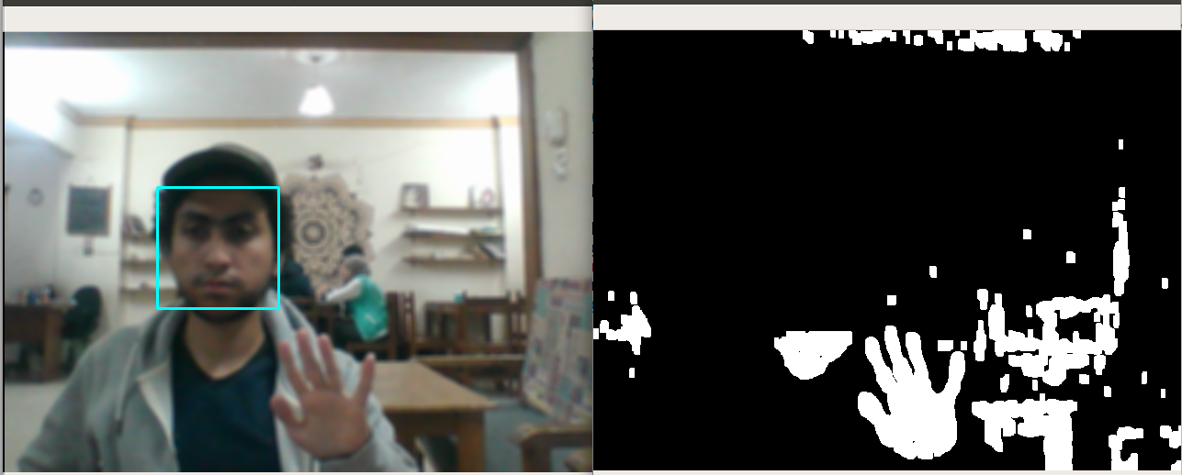Figure(3)

- regarding background subtractions, first we extracted region of interest (moving region) depending on difference among three frames.
- as shown in Figures(4,5,6,7,8)
  - as long as hand moves, it works well.
  - If nothing moves, outputs black images.
  - We tried to handle this problem by keep tracking of the moving previous area, but it doesn’t give good results as it always show the Palm of the hand.

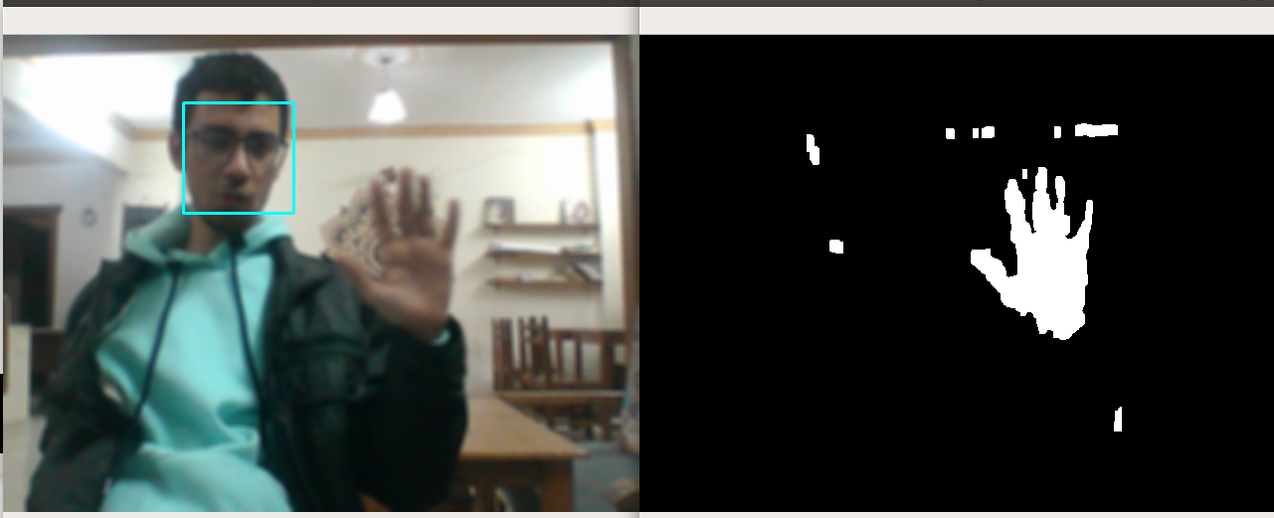Figure(4)

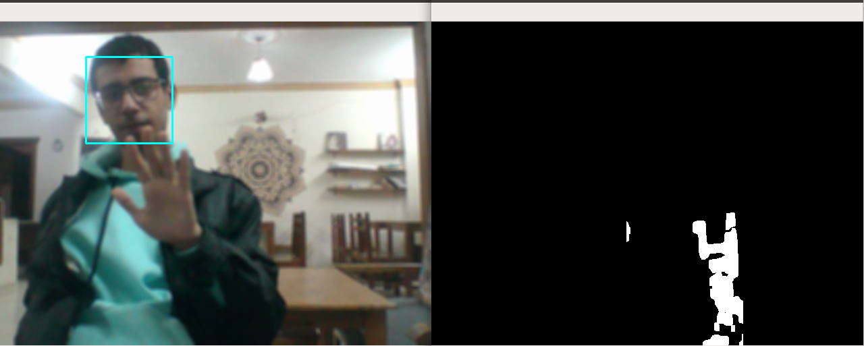Figure(6)
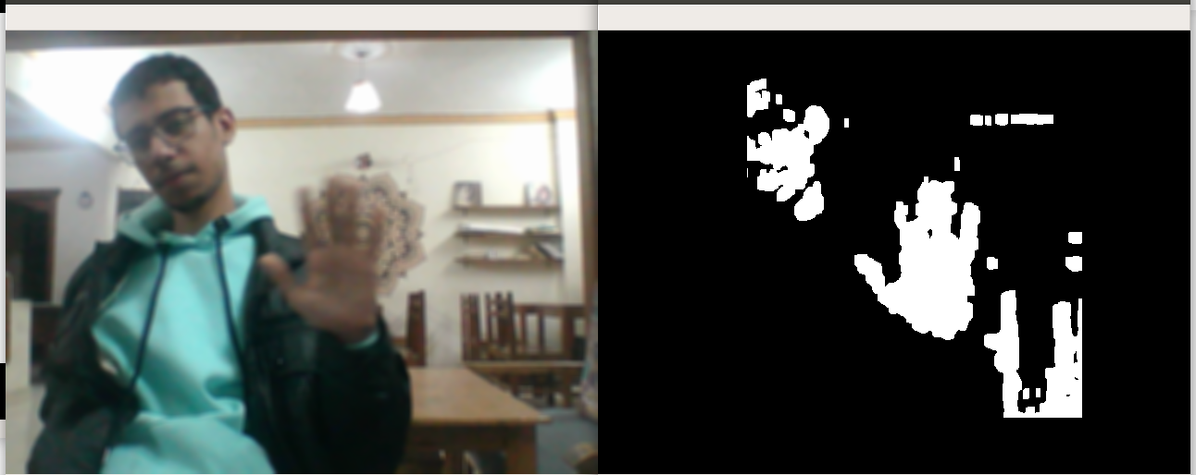Figure(5)

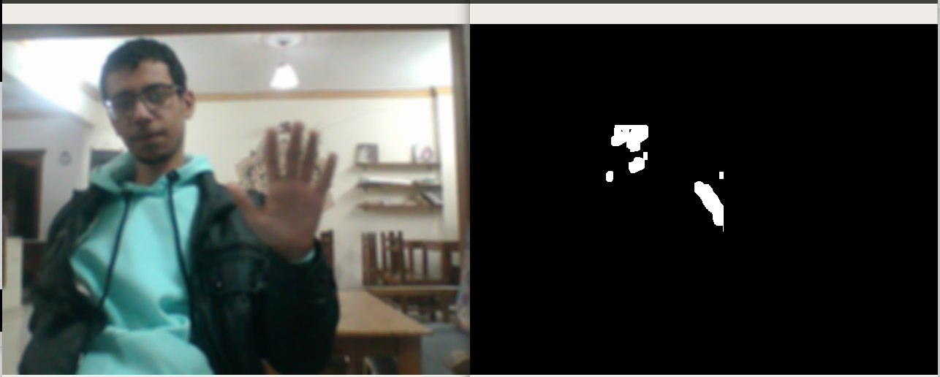Figure(7)
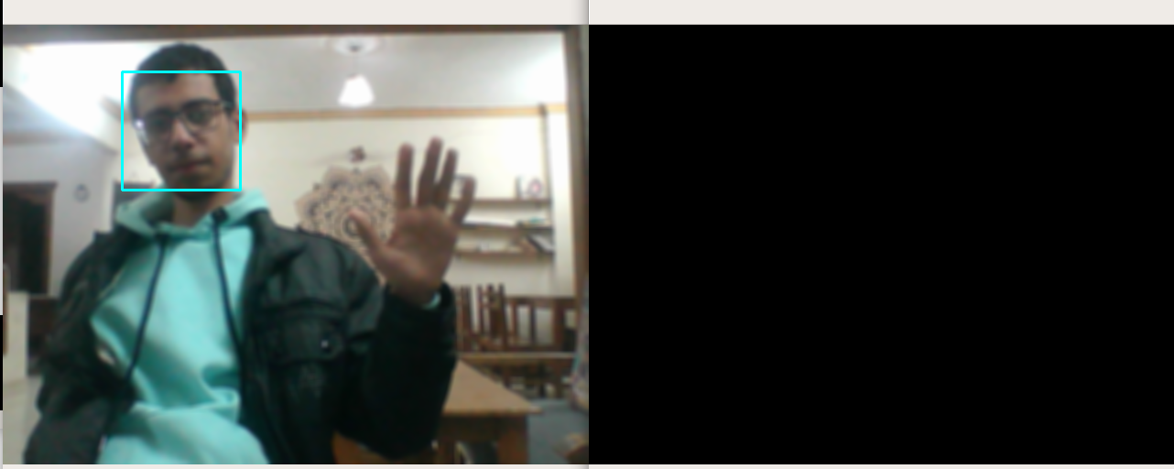Figure(8)

- So we finally used, a background subtraction method which has a dynamic background model, updated regularly from previous frames to calibrate itself.
- We subtract it from the current frame to get the foreground image as shown in Figure(9).
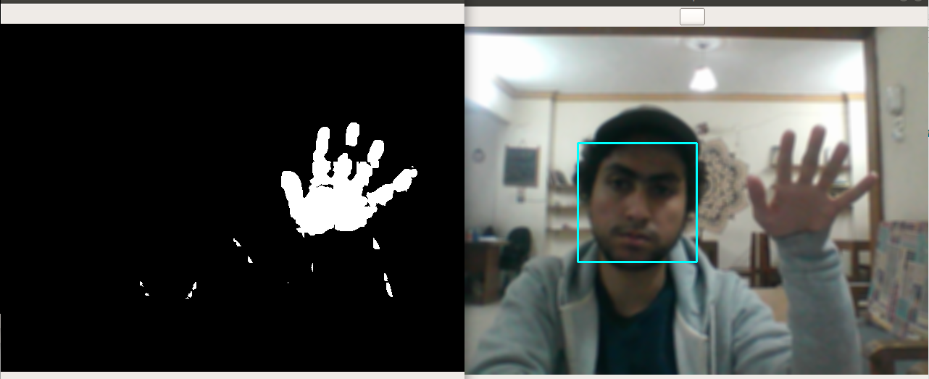Figure(9)

